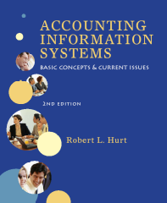

- Reading review questions

  - What four common classifications are often associated with computer crime? Carter’s taxonomy includes: target (where the computer is the object of the crime), instrumentality (where the computer is instrumental in committing the crime), incidental (where the computer simplifies criminal action) and associated (where the presence of computers has created new forms of crime).
  - What computer-crime related risks and threats are associated with information systems? The chapter discusses eleven types of risks and threats: fraud, error, service interruption & delays, disclosure of confidential information, intrusions, information theft, information manipulation, malicious software, denial of service attacks, web site defacements and extortion.
  - What categories are commonly associated with computer criminals? Describe each category. “Script kiddies” use code written by others to perpetrate computer crime. Hackers may be motivated simply by the challenge; cyber-criminals, by the potential for financial gain. Organized crime has also made significant inroads in computer crime. Corporate spies may be former employees or consultants, attempting to compromise an organization’s information system. Terrorists have also become involved in computer crime; and, corporate insiders may engage in computer crime if disgruntled or otherwise unhappy.
  - How can organizations safeguard against computer crime? How can they detect it and recover from it if it happens? What role does COBIT play in those tasks? Organizations can safeguard against computer crime via a strong system of internal controls. Internal controls can focus on the CIA triad: confidentiality, integrity and availability of information. Information systems controls fall into three major categories: physical (such as fire suppression systems), technical (such as requirements for strong passwords) and administrative (such as procedures manuals). COBIT stands for Control Objectives for Information and Related Technology; developed by the Information Systems Audit and Control Association (ISACA), COBIT can guide managers and others in developing a strong internal control system.
  - What is COBIT? What are the seven information criteria discussed in the COBIT framework? COBIT is a set of standards which gives accountants and other information systems professionals clear guidance in establishing strong internal controls, thereby deterring fraud. The seven information criteria are: effectiveness, efficiency, confidentiality, integrity, availability, compliance and reliability of information.
  - Respond to the questions for this chapter’s opening vignette.
    - What broad categories can be used to describe computer crime? Computer crime can refer to any or all of the four categories described in Carter’s taxonomy: target, instrumentality, incidental or associated. Computer crime can also be described based on the risks / threats it poses to an information system, such as fraud, error, information theft or extortion.
    - How can accountants help safeguard organizations against computer crime? Accountants can help organizations safeguard against computer crime by: establishing a strong system of internal controls; educating colleagues about COBIT and forms of computer crime; ensuring that adequate physical, technical, and administrative internal controls exist; and generally helping to maintain awareness about computer crime and information security.

- Reading review problem

 | Credit card  case | Sapphire  case | Online gambling  case | IT manager  case
Carter’s  taxonomy | Target /  instrumentality | Target /  Instrumentality | Associated | Target /  instrumentality / associated
Business risks / threats | Disclosure of confidential information | Malicious software | Extortion | Intrusion
CIA  triad | Confidentiality & integrity | Availability | Integrity | Integrity & availability
Internal  controls | Data encryption, firewalls | Virus checking software | Firewalls, backup servers | Account removal process
CoBIT  framework | Domains: deliver and support, monitor and evaluate  Information criteria: efficiency, confidentiality, integrity, availability, reliability of information

- Making choices and exercising judgment
  - What would motivate someone to engage in computer crime? Computer criminals, like most criminals, have a variety of motivations. Some seek revenge, while others are motivated by the opportunity for financial gain. Some computer criminals engage in fraud simply out of boredom or for the challenge.
  - Choose one of the AICPA Top Ten Ttechnologies; explain how it might be used to engage in computer crime. Wireless technologies provide significant opportunities for computer crime. Criminals can use unsecured wireless networks to steal sensitive information, change a company’s financial data or impersonate employees. Viruses and other malicious software can also be introduced through a wireless network.
  - Suggest at least three specific internal controls you’d employ to prevent, detect or correct the computer crime you identified above. Firewalls, virus detection & cleaning software and encryption can reduce the opportunity for computer crime in wireless networks.
  - Brad Willman contributed to the arrest of several pedophiles in Canada and the United States. But, he collected evidence for his investigation by hacking into others’ computers. Read about this case in “Internet Vigilante” by Cori Howard in Maclean’s (6 June 2005). What model of ethics, discussed in Chapter 3, best describes Willman’s actions? Were Willman’s actions ethical? What legal action, if any, should be taken against Willman? Willman was following the utilitarian school of ethics—the end justifies the means. Willman felt justified in his hacking activity because it led to a more altruistic result. From the utilitarian point of view, then, Willman’s actions were ethical—but may not have been considered ethical according to the other schools. I believe Willman should be prosecuted for his hacking activity, in spite of the outcome.

- Field work

Because the field exercises involve original research and will vary significantly from student to student, I’m not including any suggested solutions to them. If your students produce particularly outstanding responses and you’d like to send them to me, I’ll post them on the book’s web site. Let me know if this lack of suggested responses to field exercises is a major inconvenience for you.

- Which element(s) of Carter’s taxonomy apply to each of the following situations? If more than one category applies, explain why.
  - A bookkeeper steals cash as it comes into the company. The bookkeeper later falsifies accounting entries using general ledger software to cover the trail. Incidental.
  - A bored teenager initiates a denial of service attack on his internet service provider’s information system. Target (the computer is the object of the attack) and associated (computers themselves have “created” this form of computer crime)
  - A disgruntled employee uses a previously installed “back door” into an information system to lock out other users by changing their passwords. Target (computer is the object) and instrumentality (the backdoor allows the former employee access to the information system)
  - A gang of criminals breaks into a local retail store. They steal all the store’s computers, and then later hack into them for the purpose of identity theft. Incidental (theft of assets can happen even without computers) and associated (identity theft has increased because of the presence of computers)
  - A pair of computer criminals uses e-mail to contact victims for an illegal pyramid scheme. They use money from new investors, rather than profits, to pay off old investors, keeping most of the money themselves. Incidental (illegal pyramid schemes have existed for quite some time) and instrumentality (since e-mail was used to perpetrate the crime)
  - A recently fired employee laid the groundwork for corporate espionage by installing spyware on the company’s network. Incidental (espionage is not limited to scenarios involving IT)
  - A student discovers the password to his university’s information system. He then hacks the system to change grades for himself and his friends. Target (changing data), instrumentality (computer is used to change grades)
  - A woman impersonates her wealthy employer, stealing personal information about the employer from her bank’s information system. Incidental

- Which type(s) of business risks / threats described in the chapter best applies to each situation below? If more than one applies, explain why.
  - Blackmail based on stolen information Extortion
  - Concurrent attacks against a determined target Denial of service attack
  - Digital graffiti Web site defacement
  - Discovery of customer social security numbers by external parties Disclosure of confidential information
  - Hacking Intrusions
  - Intentional modification of information Fraud
  - Mistakes in data entry Error
  - Power failure Service interruption & delay
  - Salami technique Information manipulation
  - Stealing research and development data for new products Information theft
  - Trojan horse Malicious software
- Fill in the blanks below with appropriate terms related to the types of computer criminals discussed in the chapter.
  - Insiders represent the largest threat to a company’s information systems and underlying computer infrastructure.
  - Organized crime has been getting into spamming, phishing, extortion and all other profitable branches of computer crime.
  - Terrorists could seriously disrupt power grids, telecommunications, transportation and others if they were to exploit vulnerabilities to disrupt or shutdown critical functions.
  - A script kiddie describes a young inexperienced hacker who uses tools and scripts written by others for the purpose of attacking systems.
  - Corporate spies have begun turning to computer intrusion techniques to gather the information they desire.
  - Cyber-criminals possess advanced skills and have turned to hacking, not for the challenge but for the money.
  - The term hacker originally described someone who wanted to further their knowledge of computers and attempted to push their systems to the limit.

- Classify each of the following controls as physical, technical or administrative. Then, describe each control in your own words.
  - Access control software Technical. Access control software restricts access to an organization’s information system via passwords or other means.
  - Adequate supervision of employees Administrative. Employees should be supervised to promote strong internal control.
  - Badges Administrative. Authorized employees and others can be required to wear identification badges while on an organization’s premises.
  - Encryption Technical. Encrypted data are “garbled” so that they cannot be read without decryption keys.
  - Firewalls Technical. Firewall software restricts both incoming and outgoing traffic.
  - Internal audits Administrative. Internal auditors can check systems for both security and efficiency.
  - Intrusion detection systems Technical. Organizations can employ, for example, automatic lockouts after three attempts to access a system without an authorized user name and password.
  - Locks Physical. Information systems should be kept behind locked and alarmed doors.
  - Ongoing training regarding security issues Administrative. Organizations can require online or in-person seminars on a periodic basis.
  - Security guards Physical. Security guards can restrict access to sensitive areas.
  - Security policy Administrative. A well-developed security policy can outline specific acceptable and unacceptable actions.
  - Smoke detectors Physical. If a fire breaks out, smoke detectors can help minimize the damage.
  - Universal power supplies Physical. UPS protect an organization against electrical failures.

- COBIT information criteria

Indicate which of the COBIT information criteria are violated in each of the following independent scenarios. Justify your choices.
- Financial statements for the year ended 31 December 2005 are completed and published in June 2006. Effectiveness and availability—the information is not available on a timely basis.
- A company with $1 million in annual revenues maintains an accounting information system with paper journals and ledgers. Efficiency—this company is likely too large to maintain its AIS without the benefit of information technology.
- Employee names, identification numbers, job classifications and addresses are posted on a company web site. Confidentiality and (potentially) compliance—that information should be kept confidential. If “identification numbers” refers to Social Security numbers, the company may also be violating the law.
- A careless employee spilled a soft drink on a file server. The server was damaged and could not be used for three days. Availability—the system is unavailable because of the damage.
- The CEO and CFO fail to provide the documents required by the Sarbanes-Oxley Act. Compliance—the organization is violating SOX.

- Internal controls

For each situation presented in the preceding problem, suggest one or more internal controls. Classify the controls as preventive, detective or corrective. You may find it helpful to refer back to Chapter 4 to complete this problem.
a. Procedures manuals (preventive) and internal audits (detective / corrective) can facilitate the timely production of financial statements.
b. Properly installed general ledger and / or ERP software (preventive) can increase the company’s efficiency and help safeguard its information.
c. Employee information should be password protected (preventive) and stored behind a firewall (preventive, detective).
d. A procedures manual (preventive) which prohibits food & drink around file servers could address the problem. Backup systems (corrective) and insurance (corrective) would also be helpful.
e. Independent and / or external audits (preventive, detective) can help keep an organization compliant with SOX.

- COBIT

a. What are the five IT Governance Focus Areas identified in the framework? The documents on the web site describe the focus areas as follows: Strategic alignment focuses on ensuring the linkage of business and IT plans; on defining, maintaining and validating the IT value proposition; and on aligning IT operations with enterprise operations. Value delivery is about executing the value proposition throughout the delivery cycle, ensuring that IT delivers the promised benefits against the strategy, concentrating on optimizing costs and proving the intrinsic value of IT.
Resource management is about the optimal investment in, and the proper management of, critical IT resources: applications, information, infrastructure and people. Key issues relate to the optimization of knowledge and infrastructure. Risk management requires risk awareness by senior corporate officers, a clear understanding of the enterprise’s appetite for risk, understanding of compliance requirements, transparency about the significant risks to the enterprise, and embedding of risk management responsibilities into the organization. Performance measurement tracks and monitors strategy implementation, project completion, resource usage, process performance and service delivery, using, for example, balanced scorecards that translate strategy into action to achieve goals measurable beyond conventional accounting.
b. How is CoBIT related to the COSO frameworks on internal control and enterprise risk management? CoBIT applies the principles of the COSO documents within the context of information technology. So, it specifically discusses IT-related risks and suggests internal controls for addressing them.
c. What are the components of CoBIT? How do they relate to one another? Figures 3 and 4 in the Executive Summary of CoBIT (pp. 6 and 7, respectively) illustrate the components and their relationships.
d. How would managers apply the systems development life cycle to develop strong controls using CoBIT? As stated in Chapter 8, the SDLC comprises seven parts. The table below suggests how each part would relate to a CoBIT project:

SDLC phase | CoBIT application
Initiation / planning | Recognize a need for stronger IT control
Requirements analysis | Use CoBIT objectives to assess IT control needs
Design | Work together to develop controls for each domain
Build | Create procedures manuals, training programs and systems needed for designed controls.
Test | Test controls in a subset of departments / domains / processes.
Implementation | Roll out the new controls across the organization.
Operations & maintenance | Periodically monitor the system and update as required.

e. Compare and contrast the CoBIT maturity model with the Capability Maturity Model discussed earlier in the text. Both models rely on phases / stages to describe maturity levels. But, whereas the CMM was originally focused on software (and later on business processes), the CoBIT model looks specifically at information technology. The CoBIT model does not try to measure levels, nor does it strive to move different IT processes through the levels simultaneously. Page 21 of the executive summary provides an excellent chart that discusses the levels of the CoBIT maturity model.

- The C-I-A triad contains three elements: confidentiality, integrity and availability. Refer back to one or more of the professional codes of ethics discussed in the first part of the text. How are the elements of the ethical code(s) you selected related to the triad? For example, confidentiality and integrity are explicitly mentioned in the IMA Code of Ethics.
Relevant portions of the Association of Certified Fraud Examiners’ ethical code are italicized below:
- A Certified Fraud Examiner shall, at all times, exhibit the highest level of integrity in the performance of all professional assignments and will accept only assignments for which there is reasonable expectation that the assignment will be completed with professional competence.
- A Certified Fraud Examiner shall not reveal any confidential information obtained during a professional engagement without proper authorization.
A similar analysis could be conducted for the AICPA code.

- Crossword puzzle
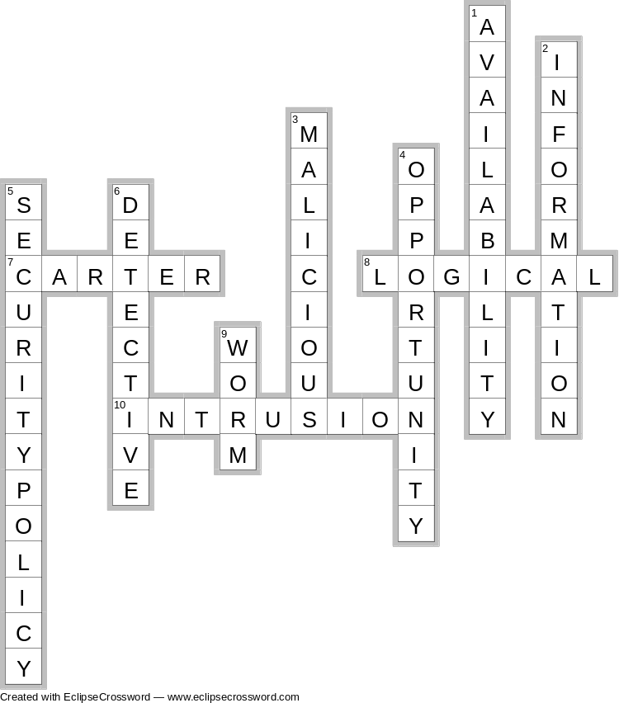

- Terminology
Please match each item on the right to the most appropriate item on the left.

- C
- F
- E
- H
- B
- A
- J
- G
- D
- I

- Multiple choice questions

    - D

    - C

    - A

    - C

    - D

    - C

    - A

    - D

    - C

    - A

- Statement evaluation

Indicate whether each of the following statements is (a) always true, (b) sometimes true or (c) never true. Explain your responses for those that are sometimes true.

- A specific instance of computer crime can involve multiple categories from Carter’s taxonomy. A
- Computer crime involves using a computer to commit a crime. B—computer crime can also involve the computer as a target, associated with or incidental to the crime.
- Computer crime is perpetrated by organized crime groups. B—computer crime can be committed by organized crime groups, but other types of computer criminals can engage in similar activities.
- Confidentiality, availability and data integrity comprise the CIA triad. A
- Each element of the CIA triad is also mentioned in COBIT’s information criteria. A
- Hackers may be motivated by profit or by entertainment. A
- Information technology controls can be physical, technical or administrative. A
- Organizations that implement COBIT are immune to computer crime. C
- Perpetrators of computer crime come from outside the organization. B—criminals can be internal or external to the organization.
- The “salami technique” is an example of information manipulation. A

